13 The Contact Page

Contents

Turn on Sass 1

Create the Contact HTML File 1

Copy the Projects.html for the Contact.html file 3

Make Changes to the Copied New HTML Page 3

Test the Page 6

Create the SASS Partial 7

Copy And Paste the home.scss to the contact.scss 8

Add the include into the top of the main.scss 9

Testing the page 12



# Turn on Sass

In Visual Studio

Remember to turn on your Watch Sass



# Create the Contact HTML File

As usual, we create the new file that will contain our new contact page.

Inside the dist folder, create a new file.

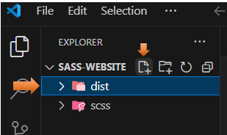

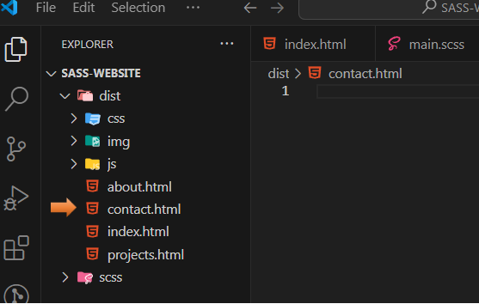

# Copy the Projects.html for the Contact.html file

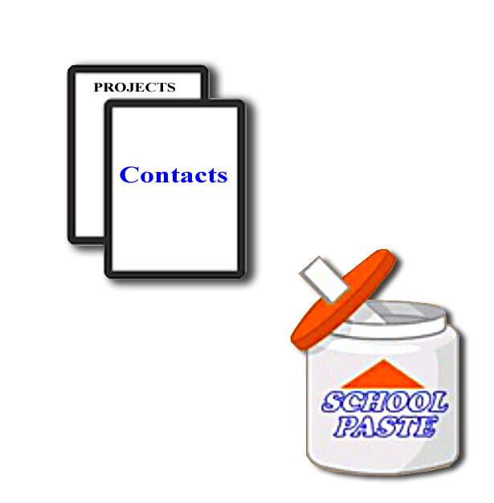

# Make Changes to the Copied New HTML Page

Change the Title

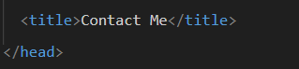

Change the active to be on the new contact menu link.

*Warning, make sure active is placed within the quotation marks of the class.

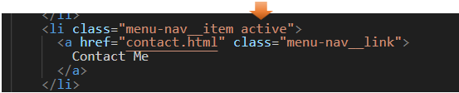

Change the section class to contact.

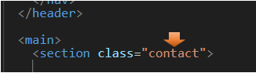

Remove all of the Project file code from inside of the section contact class

Yes, all of it after the section class, up to the div for the social icons, the section div is not closed out until after the footer on the page

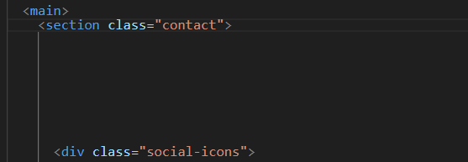

Write this code inside of that section

<h2>Contact Me...</h2>

<div class="contact__list">

<div class="contact__email">

<i class="fas fa-envelope"></i>Email

<div class="text-secondary">email@email.com</div>

</div>

</div>

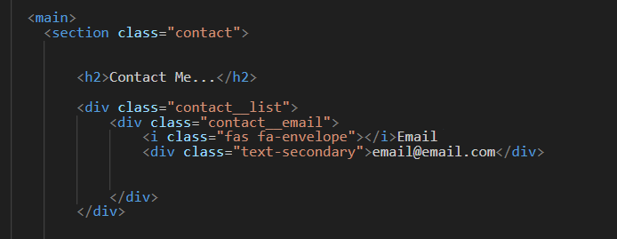

Copy and paste those two divs under the h2 tag, and paste it two more times to make three of them. Then make the following changes to the last two sections of divs.

<section class="contact">

<h2>Contact Me...</h2>

<div class="contact__list">

<div class="contact__email">

<i class="fas fa-envelope"></i>Email

<div class="text-secondary">email@email.com</div>

</div>

<div class="contact__phone">

<i class="fas fa-mobile-alt"></i>Phone

<div class="text-secondary">123-456-7890</div>

</div>

<div class="contact__address">

<i class="fas fa-marker-alt"></i>Address

<div class="text-secondary">1234 Somewhere</div>

</div>

</div>

Notice that the contact__list class div encircles the individual sections of divs.

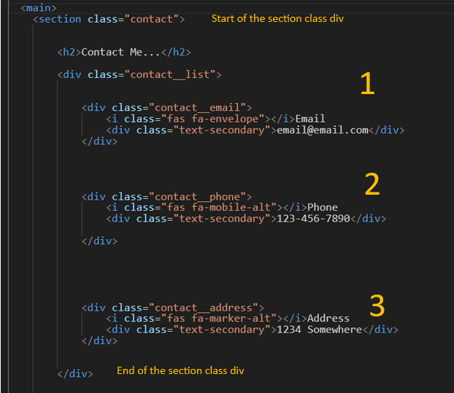

# Test the Page

Ok, now if you look at this page, it will really look like crap. Yeah, no CSS…Yet.

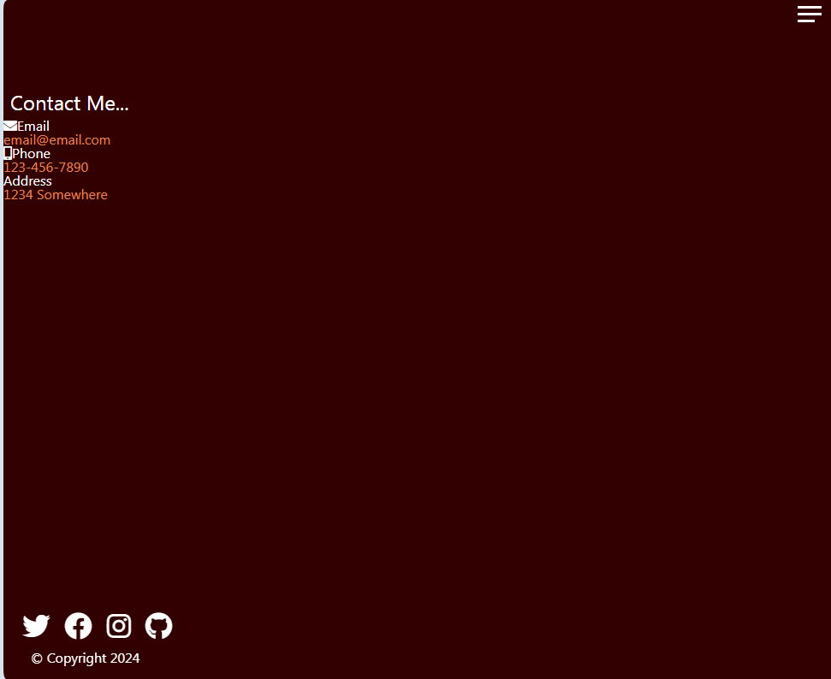

But if you click the hamburger menu, you should see that the contact page is highlighted.

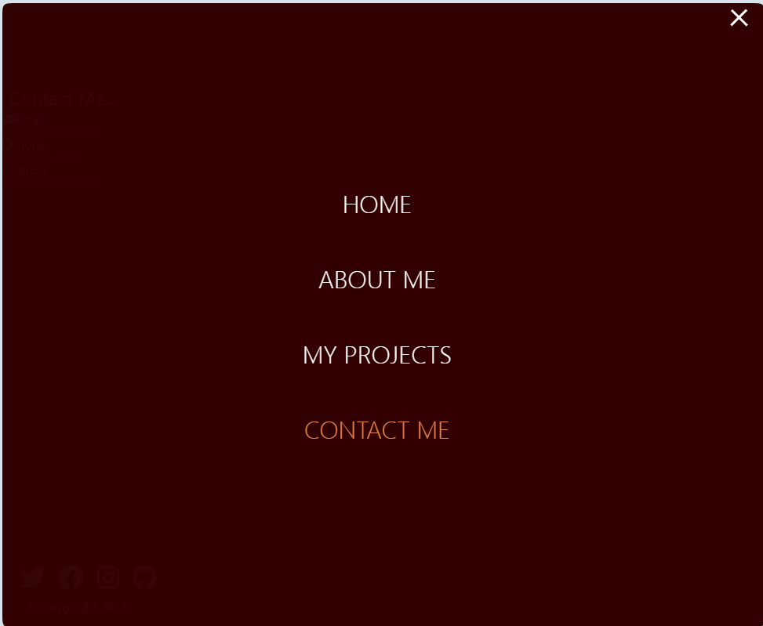

# Create the SASS Partial

Inside of the scss folder, we will be creating our contact.scss file

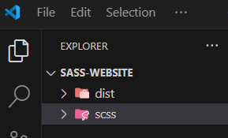

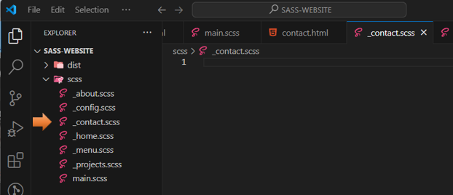

# Copy And Paste the home.scss to the contact.scss

since it will be very similar

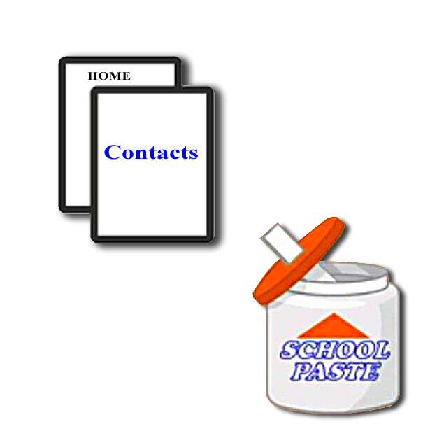

# Add the include into the top of the main.scss

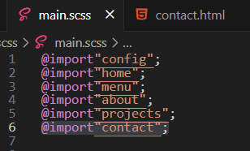

Change the name of the rule to contact.

It was home, and we need it to be contact.

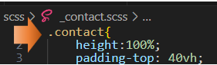

Remove this aligning to center code

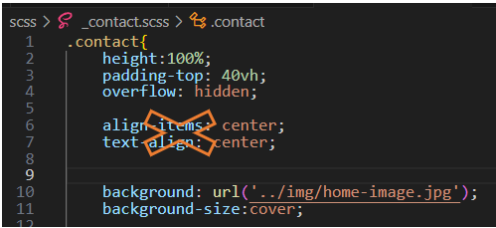

Add this code in where those two rules were.

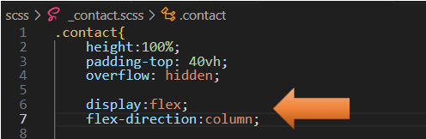

I did some changes to the logo in my image for this page, so I wanted it more customized to fit the layout

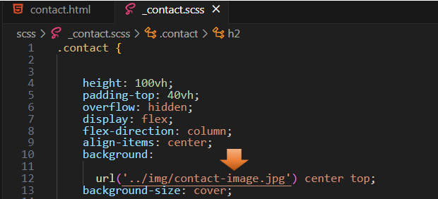

Centering the logo allowed it to fit the page better when I reduced it to a cell phone size.



Then just remove the rest of the code, but remember to leave the closing curly brace of the contact rule.

Add some room before the closing brace, we will be adding some more code to this rule.

Here, we are adding an h2 rule. The &__list will be styling the contact information on the page in a grid, and lastly we are styling the social icons.

h2 {

font-size: 3rem;

margin-bottom: 2rem;

}

&__list {

display: grid;

grid-template-columns: 1fr;

grid-gap: 2rem;

font-size: 1.5rem;

}

.social-icons {

position: initial;

margin-top: 2rem;

}

# Testing the page

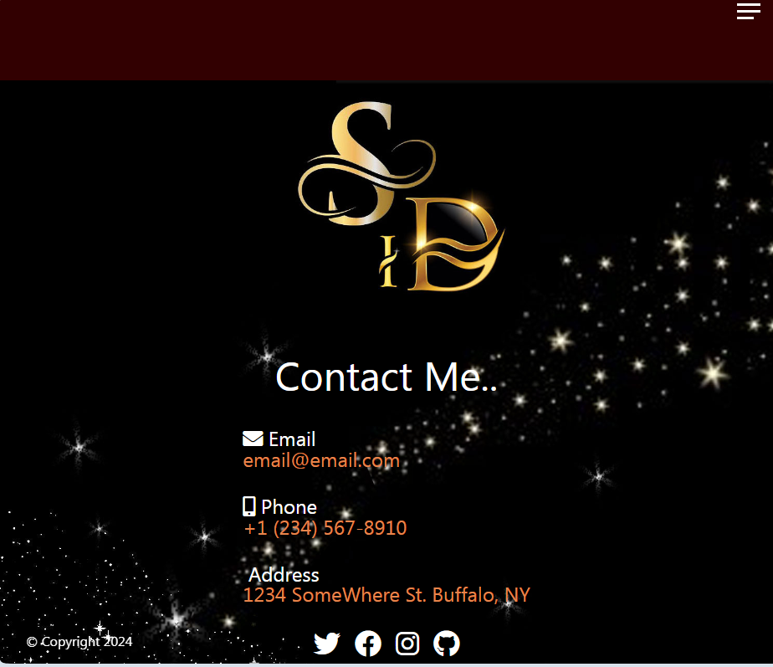

Here is a link to the full code.